3 Variables

<https://www.youtube.com/watch?v=_a5j7KoflTs>

Yes, you might say that variables are actually used inside of regular CSS, but SASS has had variable usage a lot longer than CSS has been using them.

When you use SCSS variable, they do not compile into the language of CSS, they compile straight into the actual value that is stored in the variable.

This is how you would use a regular CSS variable.

Watch it, we do everything inside of our SCSS style sheet, and nothing is done inside of the .css file. Also when you first start writing this code, it wants everything all done at once, and will show you squiggly lines until you fill some rules into the :root, so don’t freak out.

Watch it, Make sure you have Live SASS Compile in the terminal.

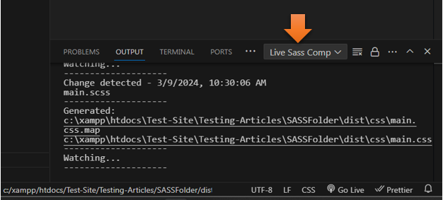

Watch it, Make sure you are in your **main.scss,** and not your main.css file

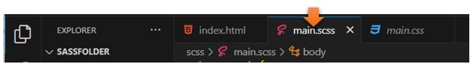

Now you can write your code.

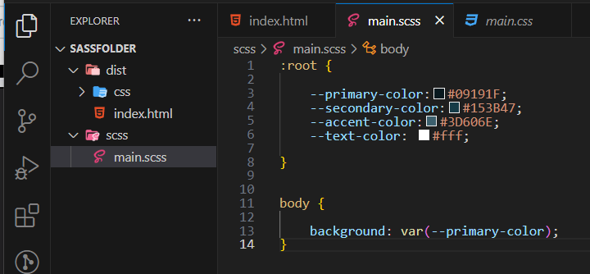

Watch it, YOU MUST SAVE IT!

The code

:root {

    --primary-color: #09191F;

    --secondary-color: #153B47;

    --accent-color: #3D606E;

    --text-color: #fff;

    }

    body {

      background: var(--primary-color);

    }

Your CSS will be identical if you look at it

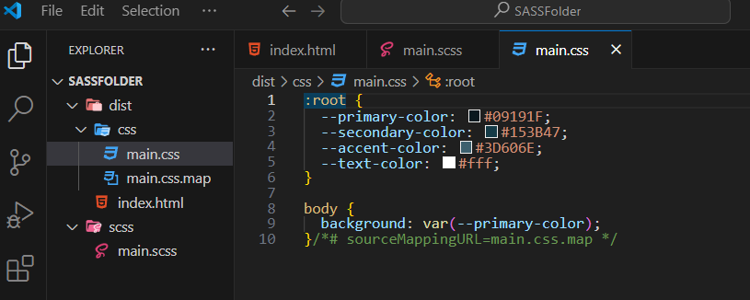

Watch it, if you want to test this, you will need to go back to the **index.html**, if you just see a file structure, you are trying to look at your CSS file, and it will not be what you want



# Using SASS variables

When you use SCSS variables, you can get rid of the root, the curly braces and the curly braces

You will add a **dollar sign** to show that this is a variable.

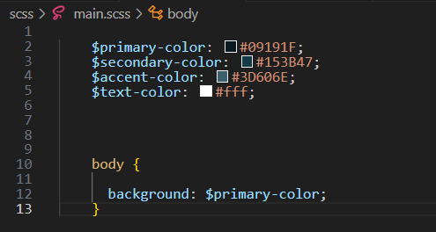

The Code

 $primary-color: #09191F;

    $secondary-color: #153B47;

    $accent-color: #3D606E;

    $text-color: #fff;

Then for the body, you can just put in the **variable name** with its little **dollar sign**.

body {

      background: $primary-color;

    }

Go to your index.html to check it, and it is still your background color



…but look at how your CSS interpreted it. This is much simpler code for the CSS file. As I said earlier, it puts the actual value of the variable in there.

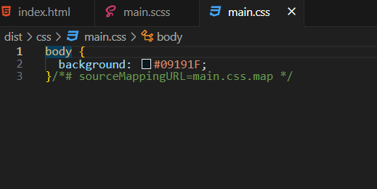

# What are Maps?

Maps are kind of like arrays, in JavaScript, or dictionaries in Python. What I mean by this is that maps are key value pairs.



And this is what a map will look like when we add it to our SCSS file

Notice the dollar sign and colon in the selector, and then the colon in the rule, every rule property (except the last one) is separated with a comma.

 $font-weights:(

        "regular": 400,

        "medium": 500,

        "bold": 700

        );

    $font-colors: (

        "light": #f2e8d4,

        "middle": #9b8559,

        "dark": #1e1401

    );

**To See this in action**, we need to add some HTML Markup to our index.html file

# To Add Lorem auto text filler

in your paragraph tab, write out the word **Lorem 50**, hit **enter** and this will give you 50 words in Lorem ipsum. You want to add this div, with a paragraph, and some text, so we can test our new styles.

**INDEX.html**

<body>

<div class="main">

<p>Lorem ipsum dolor, sit amet consectetur adipisicing elit. Temporibus rem voluptatum accusantium itaque atque eum rerum velit veniam, ratione architecto, officiis ab impedit ut assumenda quisquam. Ipsum autem laboriosam illum nobis facere, unde ea, aut nesciunt eius, a voluptas non iste consequatur soluta molestiae doloribus quae esse iusto? Vel, id!</p>

</div>

</body>

Go back to the **SCSS** file

Now remember that the CSS property for our font color is just plain **color**, so that is what we need to use.

 body {

      background: $primary-color;

      font-weight: map-get($font-weights, bold);

      color: map-get($font-colors, middle);

    }

Go back to your **Index.html** to view the file

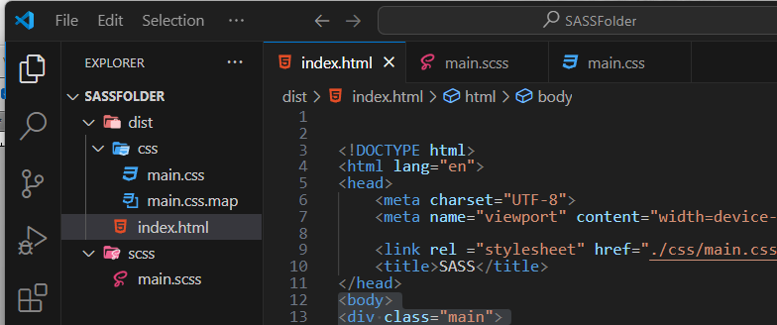

Now use the live server at the bottom to view it

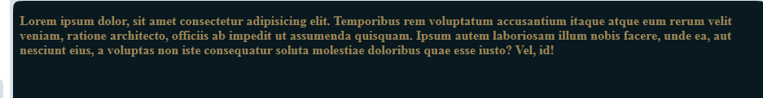

Change the SCSS to light to test it

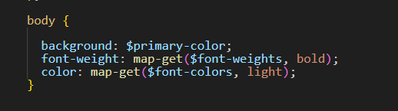

Back to the **Index.html**



Hit the **live Server** to view it in the site

and it is listening…

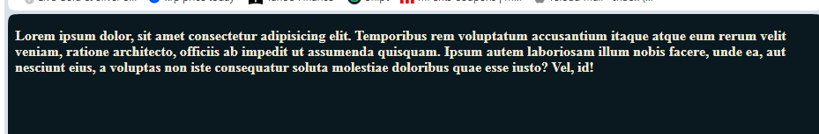

<https://www.youtube.com/watch?v=_a5j7KoflTs>

